## Customer Requirements Speciﬁcation

**SAG CRS ML Act Recog ــــــــــــــــــــــــــــــــــــــــــــــــــــــــــــــــــــــــــــــــــــــــــــــــــــــــــــــــــــــــــــــــــــــــــــــــــــــــــــــــــــــــــــــــــــــــــــــــــــــــــــــــــــــــــــــــــــــــــــــ**

**Table of Contents**

Document Status 1

Document History 1

Reference Document 2

Project Description 2

# Document Status:

|  |  |  |
| --- | --- | --- |
| **Name** | PO_ٍSAG_CRS_ML_Act_Recog | |
| **Version** | V1.2 | |
| **Status** | proposed | |
| **Author** | SAM | |
| **Date** | [18-11-2022] | |
| **Team Approval** | EID | Approved |
| **Mentor Approval** |  |  |
| **Final Approval** |  |  |

# Document History:

|  |  |  |  |
| --- | --- | --- | --- |
| **Version** | **Author** | **Date** | **Change** |
| 1.0 | SAM | [8-11-2022] | * Initial Creation * Add CRS Requirements |
| 1.1 | SAM | [18-11-2022] | * Edit CRS_REVIEW_001 * Edit CRS_REVIEW_002 * Edit CRS_REVIEW_003 * Edit CRS_REVIEW_004 * Edit CRS_REVIEW_005 * Edit CRS_REVIEW_006 * Edit CRS_REVIEW_007 |
| 1.2 | SAM | [18-11-2022] | * Edit CRS_REVIEW_008 * Edit CRS_REVIEW_009 |

# Reference Document:

|  |  |  |  |
| --- | --- | --- | --- |
| **Ref.number** | **Doc.Name** | **Version** | **Status** |
| 1 | PO_SAG_CR_ML | V1.2 | Released |

# Project Description:

## Definition:

# Activity recognition is the process of identifying the actions surrounding the blind and describing it.

## Features:

* Activity recognition.

## Key Elements:

* The activity recognition model shall describe the different activities and actions around the user.

# Activity recognition System Context:



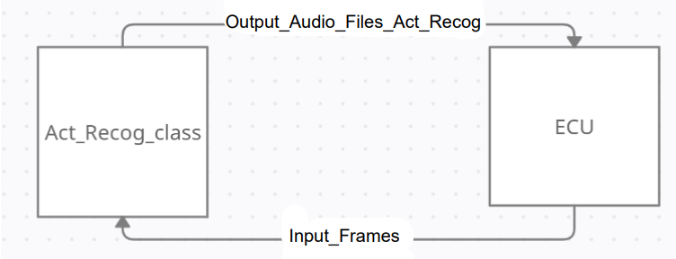

# CRS Requirements:

|  |  |  |  |
| --- | --- | --- | --- |
| **Req_ID** | PO_SAG_CRS_ML_Act_Recog_001_v1.2 | **Covers** | PO_SAG_CR_ML_003-V1.1 |
| **Description** | The Act_Recog_Class shall use resizer algorithm to resize the Input_Video_Files to suit the model. | | |

|  |  |  |  |
| --- | --- | --- | --- |
| **Req_ID** | PO_SAG_CRS_ML_Act_Recog_002_v1.2 | **Covers** | PO_SAG_CR_ML_003-V1.1 |
| **Description** | The Act_Recog_Class shall use CNN layers to process the frames to extract INN_ActRecog_Feature_Map. | | |

|  |  |
| --- | --- |
| **Info_ID** | PO_SAG_CRS_ML_Act_Recog_001_v1.0 |
| **Description** | The INN_Act_Recog_Feature_Map is an inner signal from CNN layers which represent extracted feature given to RNN. |

|  |  |  |  |
| --- | --- | --- | --- |
| **Req_ID** | PO_SAG_CRS_ML_Act_Recog_003_v1.2 | **Covers** | PO_SAG_CR_ML_003-V1.1 |
| **Description** | The Act_Recog_Class shall use RNN layers to understand the INN_Act_Recog_Feature_Map. | | |

|  |  |  |  |
| --- | --- | --- | --- |
| **Req_ID** | PO_SAG_CRS_ML_Act_Recog_004_v1.2 | **Covers** | PO_SAG_CR_ML_003-V1.1 |
| **Description** | The Act_Recog_Class shall use RNN layers to output the expressive description as text. | | |

|  |  |  |  |
| --- | --- | --- | --- |
| **Req_ID** | PO_SAG_CRS_ML_Act_Recog_005_v1.2 | **Covers** | PO_SAG_CR_ML_003-V1.1 |
| **Description** | The Act_Recog_Class shall use Text_To_Audio_formatter to format the text output to audio file. | | |

|  |  |  |  |
| --- | --- | --- | --- |
| **Req_ID** | PO_SAG_CRS_ML_actRecog_006_v1.2 | **Covers** | PO_SAG_CR_ML_003-V1.1 |
| **Description** | The Act_Recog_Class shall return Output_Audio_Files_Act_Recog to ECU. | | |